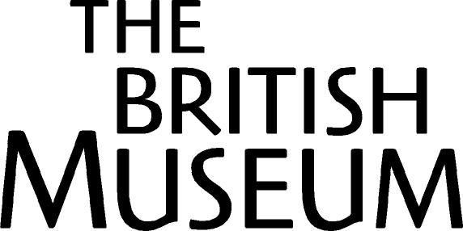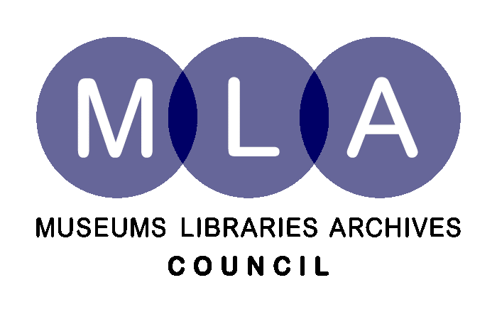

Strictly embargoed until 00.01 Tuesday 3rd October

EBAY PARTNERS WITH BRITISH MUSEUM AND MUSEUMS, ARCHIVES AND LIBRARIES COUNCIL TO PROTECT BRITISH TREASURES

The British Museum and the Museums, Libraries and Archives Council (MLA) have partnered with eBay.co.uk to ensure that antiquities found in the UK are being sold legally on its site.

In order to prevent illegal sales of treasure, the Portable Antiquities Scheme (PAS, which is managed by the British Museum on behalf of the MLA ) has set up a team to monitor antiquities sold on eBay.co.uk and to ensure that sellers have the right to trade them. Where the listing is illegal, PAS will report it to the Art and Antiques Unit of the Metropolitan Police and eBay.co.uk, which has committed to end illegal listings.The commitment is the latest development in eBay’s on-going work with national law enforcement agencies.

eBay.co.uk is the first website to reach an agreement with the British Museum and the MLA banning the illegal sale of treasure over its trading platform,

English, Welsh and Northern Irish archaeological finds which constitute ‘treasure’ must be reported to the relevant authorities under the Treasure Act. Failing to report a find of treasure is a criminal offence.

In many cases, sellers innocently trade items on the web, unaware that finds need to be reported under the provisions of the Treasure Act. eBay has therefore also worked with the British Museum and PAS to create a guide to buying and selling antiquities safely on its site with advice about reporting obligations. The guide is to be found at http://pages.ebay.co.uk/buy/guides/antiquities

Dr Roger Bland, head of Portable Antiquities and Treasure at the British Museum said: “We welcome eBay’s assistance in helping stop the illegal sale of antiquities on the internet with this partnership. Our experience is that most people who buy and sell UK archaeological finds do so without being aware that they may be breaking the law if items have not been reported. We have therefore worked with eBay to ensure that its users are aware of its obligations through our guide. We will also be contacting sellers to ensure that they have reported items and have appropriate documentation.”

Chris Batt, MLA Chief Executive added: “For those who are selling items illegally, this partnership means we have in place a process to stop listings and take action against the individuals concerned. Doing so is vital because such activity is not only illegal but could also damage the archaeological record as, without effective reporting, valuable insights into our past could be lost forever.”

David Lammy, Culture Minister comments “eBay is one of this decade’s greatest success stories. A truly global phenomenon. But like us, they recognise that the expanding internet trade in art, antiquities and antiques has potential for abuse, and it is important that steps are taken to ensure that it does not unwittingly become a cover for criminality. I commend eBay for taking such a responsible stance.”

Garreth Griffith, head of Trust and Safety at eBay.co.uk, comments: “Educating our customers on what to look out for when buying antiquities on eBay and informing sellers of their obligations is of paramount importance. Giving our customers the knowledge and engaging that knowledge to help with our investigations work means we have 15 million pairs of eyes and ears out there working with us on a day-to-day basis.

“Working with British Museum and PAS and harnessing the strength of our community of buyers and sellers means we have an extensive network to ensure that antiquities are sold legitimately. It is also an excellent example of the way that eBay can work with law enforcement to track people seeking the break the law and bring them to account.”

DS Vernon Rapley, head of the Met Police Art & Antiques unit said:
"This is a really good example of the art market and those concerned in the preservation of antiquities working together to help prevent and detect cultural property crimes. We are fully supportive of the initiative and hope that it has a real impact on preventing illicit sales."

- ends -

For further information please call

For interviews with spokespeople:

eBay.co.uk: To interview eBay’s head of Trust & Safety, Garreth Griffith, please contact the eBay press office team at Seventy Seven PR on 020 7492 0999 or email at ebay@77pr.com .

PAS: To interview Dr Roger Bland, head of Portable Antiquities and Treasure at the British Museum or for further information regarding PAS, please contact Hannah Boulton at the British Museum press office on 020 7323 8522 / 07748 162657 or hboulton@thebritishmuseum.ac.uk

MLA: To interview MLA Chief Executive Chris Batt please contact Sherene Chatfield at MLA on 07726 891176

Notes to editors
• All finders of gold and silver objects, and groups of coins from the same finds, over 300 years old, have a legal obligation to report such items under the Treasure Act 1996. Prehistoric base-metal assemblages found after 1st January 2003 also qualify as Treasure. Treasure finds must be reported by law to the local coroner, which is normally done through the finders local PAS Finds Liaison Officer. More information is available on www.culture.gov.uk or www.finds.org.uk
• Comprehensive advice on what to look out for when buying or selling archaeological material is available on the PAS website www.finds.org.uk/treasure/advice/ The site advises asking five key questions before proceeding to ensure the object can be bought or sold legally:
1. Have you legal title to sell?
2. Where was the object found?
3. When was the object found?
4. Was there a legal obligation to report the find?
5. Has the object been recorded?

About eBay
Founded in 1995, eBay pioneers communities built on commerce, sustained by trust, and inspired by opportunity. eBay enables ecommerce on a local, national and international basis with an array of websites – including the eBay Marketplace, PayPal, Skype, Kijiji, Rent.com, Shopping.com – that bring together millions of buyers and sellers every day.

• eBay.co.uk hit the 15 million users milestone in May 2006.
• eBay.co.uk has achieved the ten million live listings landmark, meaning there are more than ten million items for sale on the site at any one time*

The number of eBay.co.uk's Unique visitors reached 11.14 million in June 2006*
eBay.co.uk's reach was 41.59% in June 2006* (reach is the % of all active internet users within that month that visited eBay.co.uk)
* Nielsen Net Ratings, June 2006

About PAS

The Portable Antiquities Scheme (PAS) is a voluntary scheme to record archaeological objects (not necessarily ‘Treasure’) found by members of the public in England and Wales. Every year many thousands of objects are discovered, many of these by metal-detector users, but also by people whilst out walking, gardening or going about their daily work: in 2005/6, 57,588 objects were recorded with the Scheme. Such discoveries offer an important source for understanding our past. The PAS is mamanged by the British Museum on behalf of MLA. More information can be found on www.finds.org.uk

About MLA

The Museums, Libraries and Archives Council (MLA) is the lead strategic agency for museums, libraries and archives. It is part of the wider MLA partnership, working with the nine regional agencies to improve people’s lives by building knowledge, supporting learning, inspiring creativity and celebrating identity. The partnership acts collectively for the benefit of the sector and the public, leading the transformation of museums, libraries and archives for the future. www.mla.gov.uk

For further information and advice about how to trade safely online:

See www.getsafelonline.org for safe trading information and advice about using the internet safely.

Get Safe Online is a joint-initiative between the Home Office, Department of Trade and Industry and commercial organisations including eBay, Microsoft, HSBC, MessageLabs, and BT.

Further information can be found in the eBay Safety Centre at http://pages.ebay.co.uk/safetycentre

